Blackbaud Web Purchasing
To prepare a purchase requisition, click on the link below to go to the Web Purchasing logon page.
https://webpurchasing.ursinus.edu

The first time you use it you will need to log in using your network username and password. Any time after that it will automatically take you to the main page unless you are on a different machine or using a different browser.

General Information
Use one requisition for each vendor. Do not put more than one vendor on a requisition/order.
If ordering for more than one department make sure the you distribute evenly the costs.

Order Products
The main menu appears below. Click on ‘Go Shopping’ or the ‘Purchasing’ tab to create a purchase requisition.
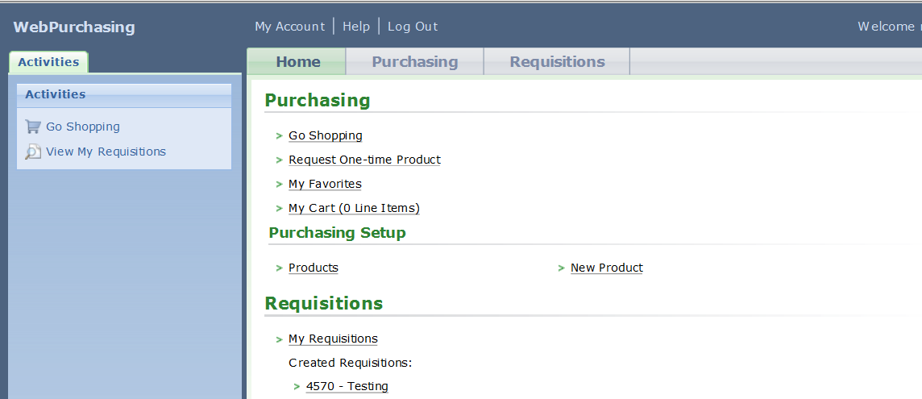

Searching for a product
A list of shopping items will appear. Search for your item by Product ID or Product Description. If you search for the item and find the item, change the quantity and click on ‘Add to Cart’. You can ‘Add to Favorites’ to accumulate a list of items you order frequently.
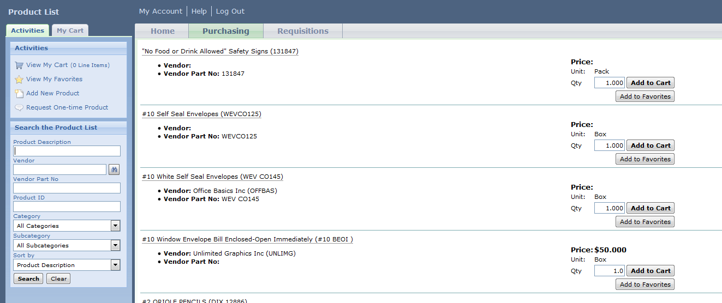
If the product that you want is not on the shopping list, you may click on ‘Request a One-Time Product’ to enter the Product and Vendor information. DO NOT ‘Add a Product’,
Request a One-Time Product:
Look up Vender to add. Type the name in the ‘Select a Vendor’ box.
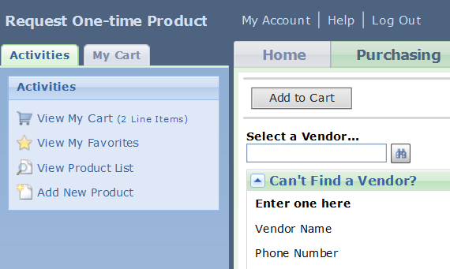

When this box comes up, click on the vendor name that you want and hit ‘Enter’.

For ‘Product Description’ put the Item number first and then a brief description. Enter the Quantity, Unit of Measure and Unit price. Click on ‘Add to Cart’.
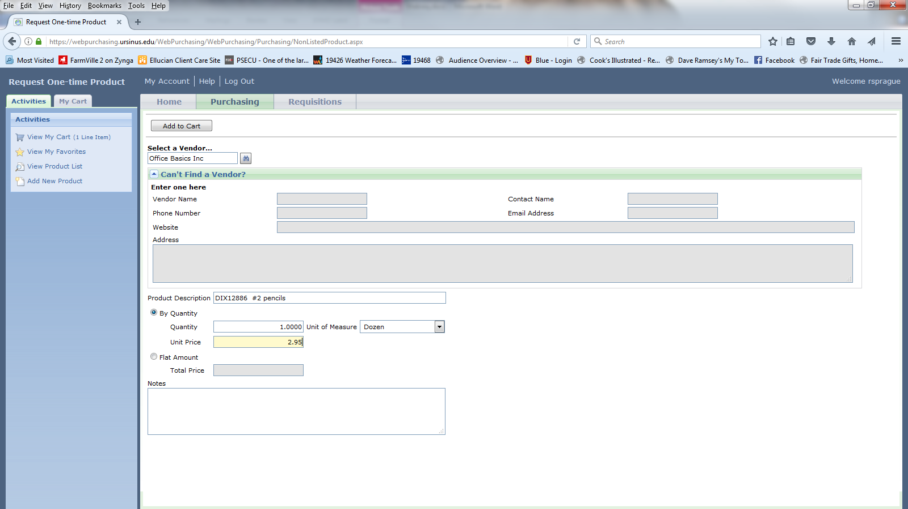

When you have added all of the items you wish to purchase to your cart, click the ‘View My Cart’.

The items in your cart will appear. If you see a yellow box, you need to fill it in. 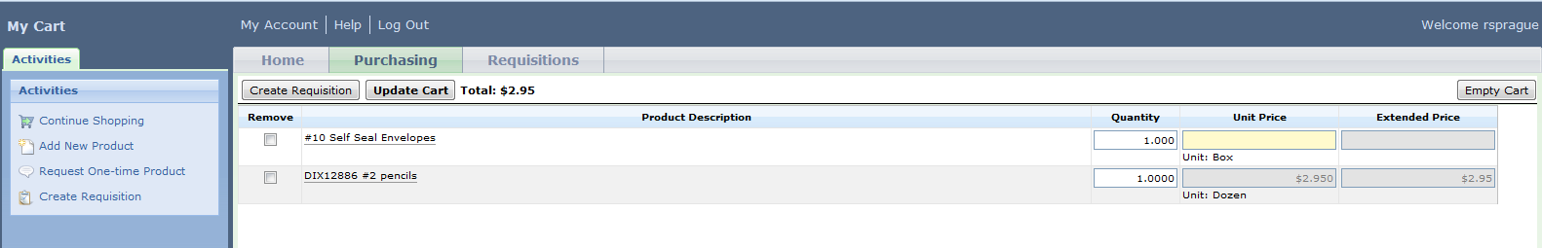

You might get a dialog box like this. Click on ‘Yes’.
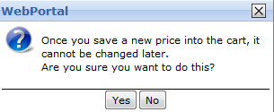

If you remove items or change quantities, click on the ‘Update Cart’ button to save the changes to your cart.
When you are satisfied with your cart, click on the ‘Create Requisition’ button.

Create the Requisition
Once you click on ‘Create Requisition’ all the items you ordered should appear. If you are ordering for more than one group, check the ‘Approval Rule’ for the correct group that you are ordering for. This is important so that the email to approve your request goes to the correct approver. You can click on ‘Show Details’ to double check that you have the right one. If you can put a description in you will be able to identify this requisition more quickly. Click on ‘Edit’ on one of the items to enter additional details.
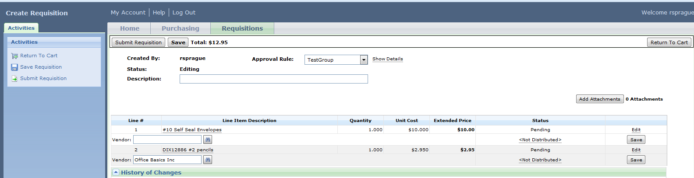

You can enter ‘External Notes’ for notes specific to the vendor or you can enter ‘Internal Notes’ for notes to Joyce in the Purchasing Office.
If Vendor box is blank search for Vendor like you did on page 3. If search does not find your vendor, contact Joyce in the Purchasing Office to add the vendor.
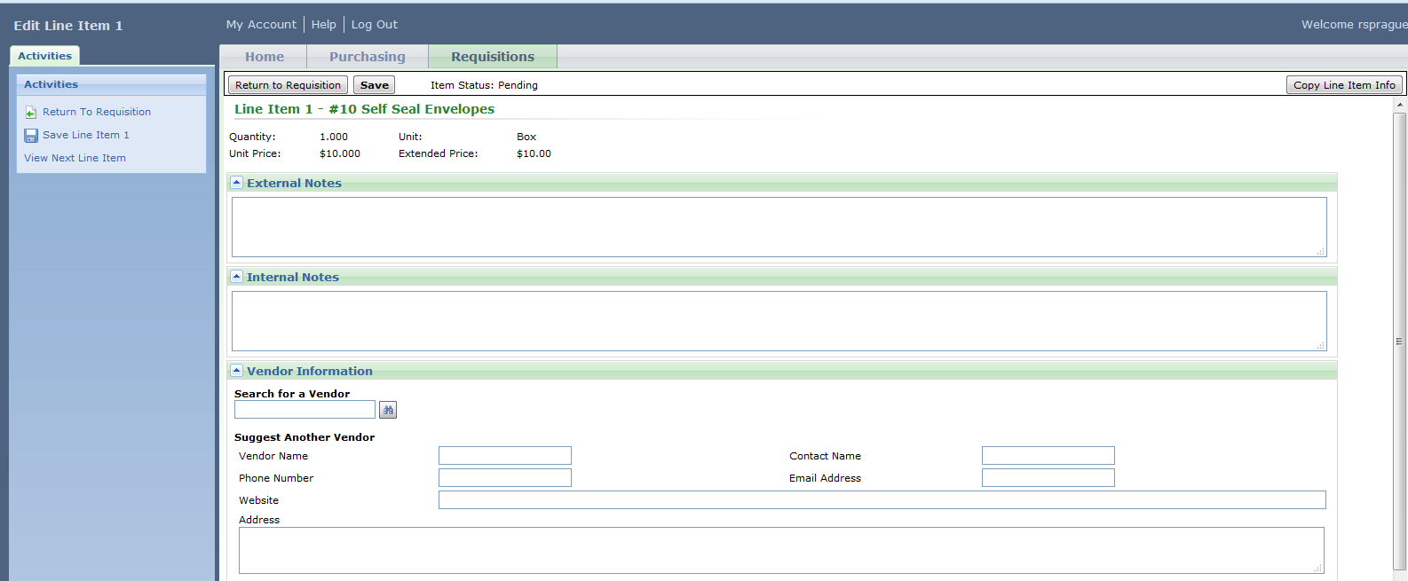

Enter ‘Date required’, ‘Buyer’ and ‘Department’. Don’t forget ‘Buyer’ so that you receive your orders!!!!!! Click on ‘Add’ for distriburion information.
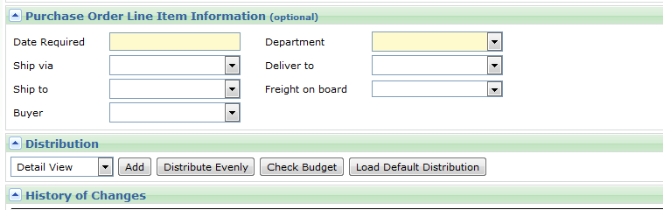

Distribute
Click on ‘Distribute Evenly’ to enter the total ‘Amount’ of the item. The number should match exactly what your ordered. Example: You ordered 2 dozen pencils at $5.00 per dozen. You should see $10.00. Enter the ‘GL account number’ where it should be charged. Make sure that you include zeros if necessary. Hit ‘Enter’ on your keyboard to automatically populate other fields on screen.
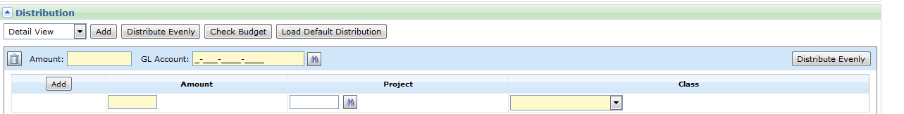

Save your line item.

If you have more than one item and they are all from the same vendor and charged to the same account, you can click on ‘Copy Line Item Info’ on the top right of your page.

If you clicked on ‘Copy Line Item Info’ you will be asked what info you want to carry over to the other items. You click the boxes for the Vendor Informtion, the PO Information and the Distribution.Click on ‘OK’
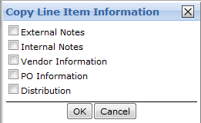
Click on ‘Return to Requisition’.

Click on ‘Submit Requisition’. An email will be sent to the approver(s) to notify them of the requisition. After final approval, the requisition will be available to Purchasing to generate the Purchase Order. If you have set the options to receive emails in the ‘My Account’, you will receive an email at each step.
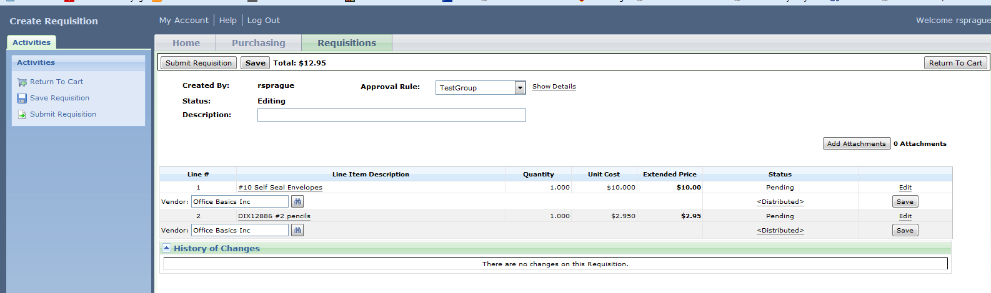

This is the message that you will receive when you ‘Submit Requisition’. You can click in the message to look at the requisition and print it out through the browser. You might want to print it out or note the Requisition # (PR#) for future reference.
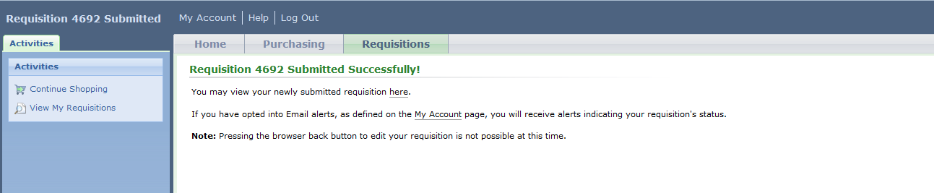
If you would like to see the status of the requeistion, click on the ‘Requisitions’ tab. Locate the number of the requisition that you created by searchhing or scrolling throught the list.
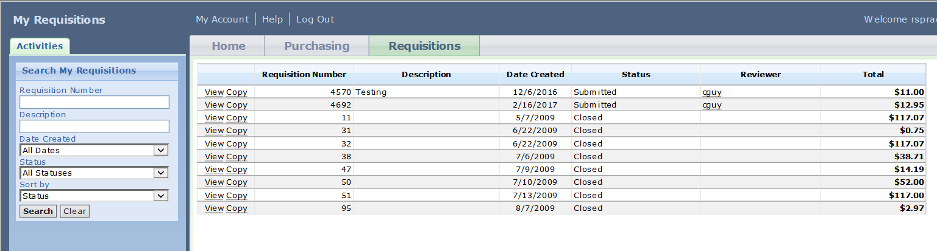

At the bottom of the screen under ‘History of Changes’ you will see the status. You will, also, receive an email if you set your account up to notify you.
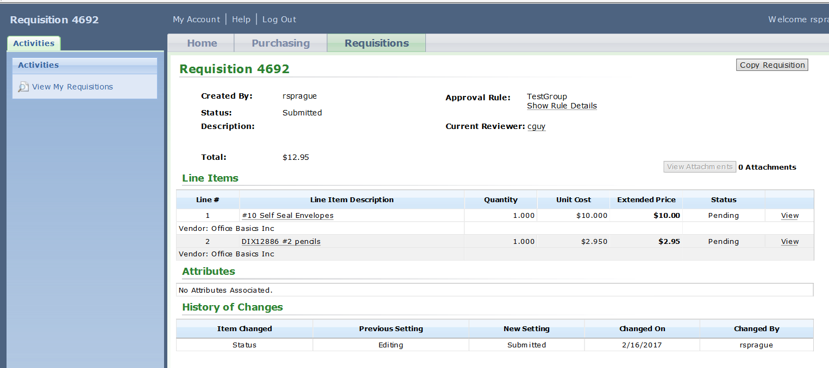

Once the Purchase Order has been created, you can get the PO# that was created by Joyce in Purchasing by ‘View the Requisition’ and then ‘View’ on the line item.

