SECOND DEGREE OPTION: BSNExpress Program

Villanova University M. Louise Fitzpatrick College of Nursing offers a full-time option to motivated students with a bachelor’s degree in another discipline who wish to embark on a career in nursing. The BSNExpress Program is an accelerated program that permits completion of the Bachelor of Science in Nursing (BSN) degree in 14 consecutive months. It incorporates all the standard components of the traditional nursing program but in a different timeframe.

BSNExpress PROGRAM
• Begins in May; ends in August of following year
• Online application with rolling acceptance
• Application deadline: October 15th
• 3.0 GPA or higher is minimum requirement
• Prerequisites may be taken at Villanova or any
accredited college or university

Anatomy & Physiology (8 credits)
Chemistry (4 credits), must have organic component
Microbiology (preferred) or Genetics (3–4 credits)
Pathophysiology (3 credits)
Nutrition (3 credits)
Science Elective (3-4 credits)
Statistics (3 credits)
Theology/Religious Studies (3 credits)
English/Literature (3 credits)
Philosophy (3 credits)
Humanities electives (9 credits)
Intro to Psychology or equivalent (3 credits)
Intro to Sociology or equivalent (3 credits)
Human Development (lifespan) (3 credits)
Social/Behavioral Elective (3 credits)

For current tuition and other costs, visit the
BSNExpress FAQ section of our web site at
www1.villanova.edu/villanova/nursing/programs/undergrad/second/bsnexpress/faq.html.

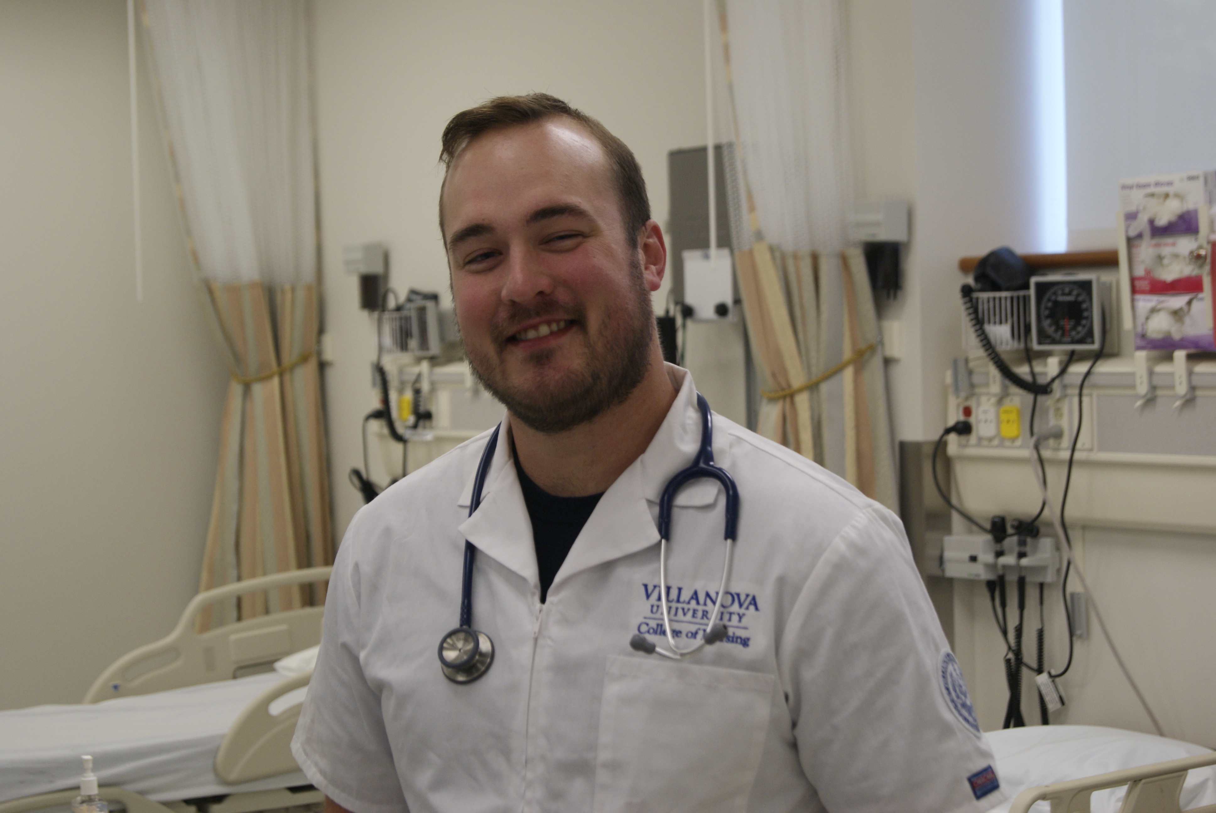

FIND OUT MORE
Students are encouraged to submit copies of their college transcripts well in advance of their planned entrance into the program in order to allow for complete evaluation,
transfer of credits and appropriate advisement. Unofficial transcripts are acceptable for initial review. For more information about applications, transcript
evaluation, TOEFL, financing your education and more visit our second degree pages at
www.villanova.edu/nursing/programs/undergrad/second.

You may also want to visit Villanova’s Office of Financial Assistance at www.finaid.villanova.edu.

Questions? Contact Cheryl Wert at cheryl.wert@villanova.edu or 610.519.5633.

