The Effectiveness of Sunblock and Protective Materials
Introduction
Light is composed of tiny units called photons, just as matter is composed of tiny units called atoms. Each photon has a wavelength and energy associated with it. A photon with a long wavelength has low energy, while a photon with a short wavelength has high energy. (Does an ocean with long smooth waves or short choppy waves have more energy?) Visible light, which our eyes can detect comprises a very small portion of the light spectrum. The different types of light are divided into gamma, x-ray, ultraviolet (UV), visible (vis), infrared (IR), microwave, and radiowaves, depending on the wavelength of the photon. Ultraviolet light, what we often fear from the sun, is also subdivided by wavelength into three ranges: UV-A, UV-B, and UV-C, with UV-C being the shortest, most energetic and most fearsome.
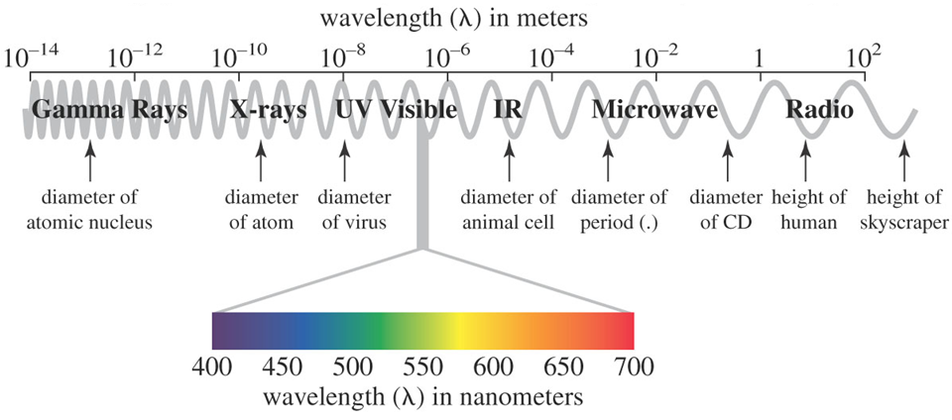
Figure 1. The electromagnetic spectrum.

In this experiment, you will use a spectrophotometer to explore aspects of ultraviolet light. A spectrophotometer (or spectrometer) contains a light source, a system of optics to break light into different components, a sample holder (called a “cuvette” in spectroscopy), a detector, and a digital display. The basic components of a simple spectrophotometer are shown in Figure 2. Transmittance tells how much light pass through a substance while absorbance tells how little light passes through a substance. For example, a piece of thick black paper has zero transmittance or 100% absorbance of visible light. A clear colorless piece of glass has close to100% transmittance and 0% absorbance of visible light. Using the spectrometer, you will monitor the amount of light absorbed or transmitted by various samples at different wavelengths of light.

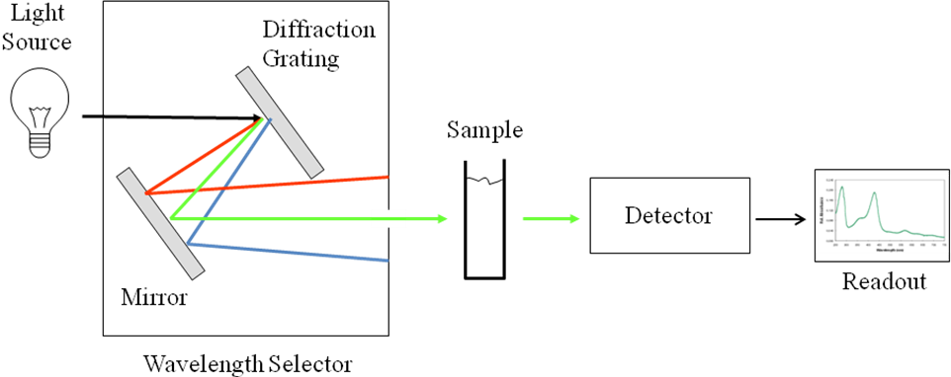
Figure 2. Schematic of the components of a spectrophotometer.

In this experiment, you will study invisible light in the ultraviolet region of the electromagnetic spectrum. The UV region encompasses radiation wavelengths from 100 to 400 nm, and is divided into three ranges: UV-A (320 – 400 nm), UV-B (280 – 320 nm), and UV-C (100 – 280 nm). While photons in the visible region possess only enough energy to cause electrons to change energy levels within a molecule, photons in the UV region are sufficiently energetic to break bonds in biological molecules, causing tissue damage. Photons in the UV-A range have the longest wavelength, are the least energetic and the least damaging. Photons in the UV-B range are intermediate in energy and potential for damage. Fortunately, some UV-B radiation is absorbed by the stratospheric ozone layer. UV-C radiation is the most energetic and most damaging to living organisms; however, it is totally absorbed by ozone and oxygen in the stratosphere.
There are two investigations regarding ultraviolet light. First, you will use the spectrometer to monitor the UV absorbance of different sunscreens. The sunscreens are dissolved in isopropanol (rubbing alcohol) at equal concentrations prior to use. Based on the UV absorbing capabilities of the different sunscreens, you will be expected to make an assessment regarding the effectiveness of each product (role of SPF factor, brand name vs. generic, etc.) Then, you will design a procedure to determine the effectiveness of various materials at protecting us from UV radiation using UV sensitive beads. The beads turn from white to red in the presence of UV light. The longer it takes for the beads turn red, the more effective the material is at shielding the beads (or us) from UV radiation. Protective materials for use in this procedure include: glass, plastic wrap, thin cotton fabric, various sunscreens, sunglasses, and water.

Safety:
- Always wear goggles in the lab.
- Wash your hands with soap and water if you get any solution on you.
- The quartz cuvets are very expensive. Be careful not to break them.

Procedure:

Part 1: Absorbance of Ultraviolet Radiation by different Sunscreens

- You will investigate two hypotheses regarding sunblock:
  - How does the absorbance of a sunscreen with an SPF of 50 compare to the absorbance of a sunscreen with an SPF of 30? Of 8 and 4?
    - Hypothesis “A” will compare Coppertone ultraguard 50, Banana boat scalp spray 30, Hawaiian tropic 8, and Hawaiian tropic 4
  - Do mineral-based sunscreens work better than chemical-based sunscreens?
    - Hypothesis “B” will compare Banana Boat Kids 50+ (pure mineral based), Coppertone Defend 50 (both mineral and chemical components), and Coppertone Ultraguard 50 (just chemical components)
- Turn the LabQuest2 screen on (by touching it). Then, using the stylus, click on the Mode icon. Change the wavelength range to 100-400 nm. Click ok.
- Without a sample in the spectrophotometer, click on the red USB: Abs button. Select “calibrate”. When it says to “place a blank cuvette in the device”, insert the cuvette with isopropanol (facing the correct way!), then click “finish calibration”. Once it’s done, click OK. (If this screen comes up any other time you are working with the spectrophotometer, make sure you use the isopropanol cuvette, not one of your samples!)
- Place your first sample into the spectrophotometer (facing the correct way!). Click the green “play” button on the bottom left of the screen. Record the color of the line so you can identify it again later in Data Table 1 below.
- Place your next sample into the spectrophotometer. Click the green “play” button. Now the LabQuest will ask you if you want to store or discard the previous data. Select “store”. The data will begin collecting; again after a moment click the red square to stop collection. Again, write down the color of the line in Data Table 1.
- Repeat this for the remaining samples involved in your hypothesis “A”.
- Once all samples for hypothesis “A” are complete, click the icon that says “Run #” then select “All Runs”. Now all four sunscreen spectra will show.
- Your LabQuest should be connected to a SIM printer. Ask your instructor or the SIM educator for help printing your graph.
- Now go back to your work area, make sure all your equipment is plugged into each other. On the LabQuest select “File” then “New”. A message will come up – select “discard”.
- Repeat the methods to analyze your second hypothesis.

Part 2: How to Protect Ourselves from UV Radiation

- Now you will investigate the following hypothesis:
Which material is most effective at shielding the UV sensitive beads from UV radiation?
Select three of the materials provided to compare and write them Data Table 3 (below).
- Design a procedure (write it out in your notebook!) using 3 of the UV sensitive beads per test and three different protective materials. You will need to take the beads outside to a shaded location. Remember to protect the beads from all sides and design control experiments for comparison. You should do multiple (at least 3) trials for each set of experimental conditions to see if you can duplicate the results. The beads should be kept in the dark until you are ready to use them; they will eventually change back to white when placed in the dark (your pocket works well).
- Make a table of results, indicating the time it takes for the first appearance of color, and how dark the color of the beads appear after several minutes (use the same time for all trials).

DATA and ANALYSIS

Table 1. Absorbance of sunscreens with different SPF (Hypothesis “A”)
Sunscreen | Line color on LabQuest graph
Coppertone Ultraguard 50
Banana Boat Scalp Spray 30
Hawaiian Tropic 8
Hawaiian Tropic 4

Table 2. Absorbance of sunscreens with different compositions
Sunscreen | Composition Type | Line color on LabQuest graph
Banana Boat Kids 50+ | Pure mineral based
Coppertone Defend 50 | Both chemical and mineral based
Coppertone Ultraguard 50 | Pure chemical based

Table 3. UV protection of various materials
Material | Time to first pink color of beads (s)

- How did SPF affect the effectiveness of the sunblock?
- How did chemical composition affect the effectiveness of sunblock?
- According to your data, which is the best sunblock to protect against UV radiation?
- Rank the materials you tested in Part 2 from least protection to most:
- Compare the use of sunblock to the materials. Which provides the most UV protection?
- How much greater should the absorbance be for an SPF 30 sunscreen than an SPF 15 sunscreen? Is your data consistent with this?

