Sound Waves and Beats
Name:

Partner’s Name:
Sound waves consist of a series of air pressure variations. A Microphone diaphragm records these variations by moving in response to the pressure changes. The diaphragm motion is then converted to an electrical signal. Using a Microphone and a computer interface, you can explore the properties of common sounds.
The first property you will measure is the period, or the time for one complete cycle of repetition. Since period is a time measurement, it is usually written as T. The reciprocal of the period (1/T) is called the frequency, f, the number of complete cycles per second. Frequency is measured in hertz (Hz). 1 Hz = 1 s–1.
A second property of sound is the amplitude. As the pressure varies, it goes above and below the average pressure in the room. The maximum variation above or below the pressure mid-point is called the amplitude. The amplitude of a sound is closely related to its loudness.
When two sound waves overlap, their air pressure variations will combine. For sound waves, this combination is additive. We say that sound follows the principle of linear superposition. Beats are an example of superposition. Two sounds of nearly the same frequency will create a distinctive variation of sound amplitude, which we call beats. You can study this phenomenon with a Microphone, lab interface, and computer.
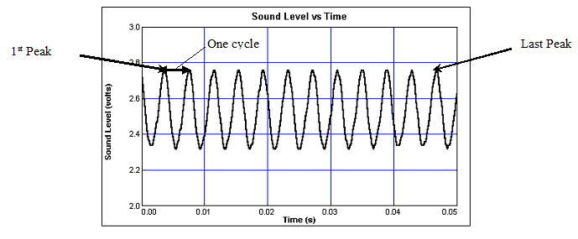objectives
- Measure the frequency and period of sound waves from tuning forks.
- Measure the amplitude of sound waves from tuning forks.
- Observe beats between the sound of two tuning forks.

Materials
LabQuest | Vernier Microphone
LabQuest App | 2 tuning forks 300 Hz – 500 Hz range

Procedure
Part I Simple Waveforms
- Connect the Microphone to LabQuest CH 1 and tap File - New.
- With the room quiet, Tap Sensors - Zero. When the process is complete the reading for the sensor should be close to zero.
3. To make a sound with a tuning fork, strike it against a soft object such as a rubber mallet or the rubber sole of a shoe. Striking it against a hard object causes damage Properly strike the tuning fork then hold it close to the Microphone and tap the green start arrow on lower left of screen. Your graph should be similar to the sample on the front page of this lab.
4. Tap the peak of the first wave and record the time value in the data table. Do the same thing for the last peak. Subtract to calculate Δt. Record the number of complete cycles between your first and last peaks. See diagram on front. Divide Δt, by the number of cycles to determine the period of the tuning fork. Record the period in your data table.
Calculate the frequency of the tuning fork in Hz and record it in your data table.
frequency = 1 / period
5. Tap the first peak again and record in the middle data table the sound level in volts. Tap a trough and record the sound level in volts.
6. Calculate the amplitude of the wave by subtracting the trough from the peak sound levels then divide the answer by two. Be careful with the math; you are subtracting a negative number. Record the values in your data table.
7. Strike the same tuning fork harder than before to produce a louder sound, hold it close to the microphone and tap the green start arrow. Repeat steps 5-6 for the louder peak and trough.
8. Repeat the lab with a different frequency tuning fork.

Part II Beats
9. Tap Meter icon at top left of screen. Tap Rate. Change the rate to 2500 samples/second and the duration to 0.10 seconds. Tap OK.

10. Strike the two tuning forks equally hard and hold them the same distance from the Microphone. Tap the green start arrow.
11. The pattern will be complex. Look at the overall larger pattern, count the number of amplitude maxima after the first one and record it in the data table as the number of cycles. See the sample provided by the teacher.
12. Tap the first maxima and record the time in seconds. Tap the last maxima and record the time in seconds. Subtract those times to find Δt. Divide Δt by the number of cycles to determine the beat period (in s). Calculate the beat frequency in Hz from the beat period.
Beat frequency = 1 / beat period

Preliminary questions
- Why are instruments tuned before being played as a group?
- How do musicians tune a string instrument? A brass instrument?
- What would happen if an air pressure increase from one sound wave overlapped a pressure decrease from a second same volume sound wave?

Data Table
Part I Simple Waveforms
Tuning fork frequency | Number of cycles | First maximum (s) | Last maximum (s) | Δt (s) | Period (T) (s) | Calculated frequency(f) (Hz)
1
2

Tuning fork frequency | Peak  (V) | Trough  (V) | Amplitude  (V) | Louder Peak  (V) | Louder Trough  (V) | Louder Amplitude  (V)
1
2

Part II Beats
Number of cycles | First maximum (s) | Last maximum (s) | Δt (s) | Beat  Period (s) | Calculated beat frequency (Hz)

Analysis
Part I Simple Waveforms
1. On graph A, draw a wave of the same frequency that is louder than the original wave.
- On graph B, draw a wave of the same loudness that has a higher frequency than the original wave.
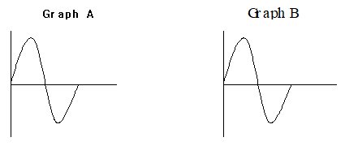

Part II Beats
3. Using the frequencies that are stamped on your two tuning forks, subtract to calculate the beat frequency. Show all work. Compare your answer with the calculated beat frequency in the data table.

